No. | Problem | Suggestion | Confirm
1. | As below image shown, the arrow indicated hole have same size copper pad on both sides, and there are no other components to connect with the hole. Could you please help to confirm if we can build the arrow indicated hole as NPTH?  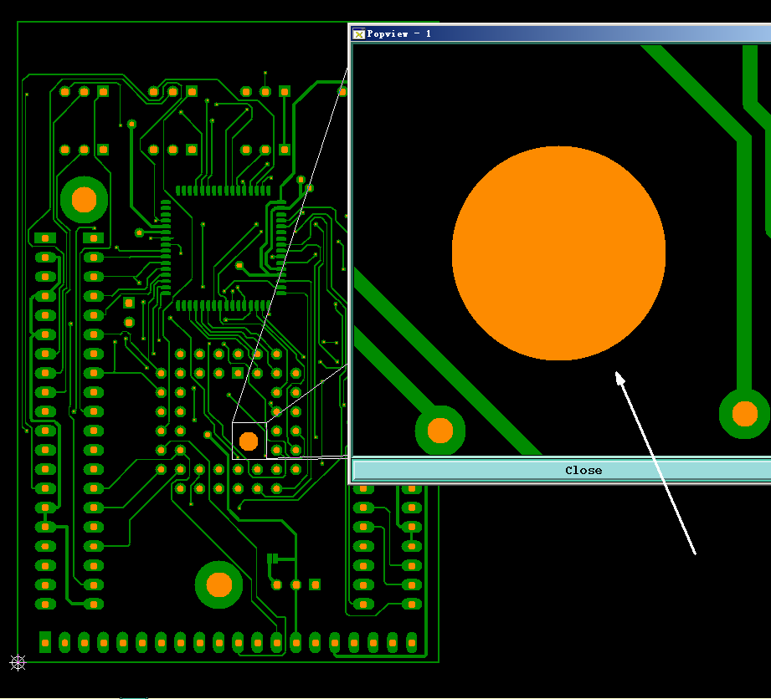 | Suggestion:  Make the arrow indicated hole as non-plated hole. | Hole should be NPTH.
2. | As below image shown, some texts in your original gerber have stepped on the pads, and there are no enough space for moving these texts. We will clip off these texts which step on the pads, and the texts will be fuzzy and incomplete. Could you please help to confirm if fuzzy and incomplete texts are acceptable?  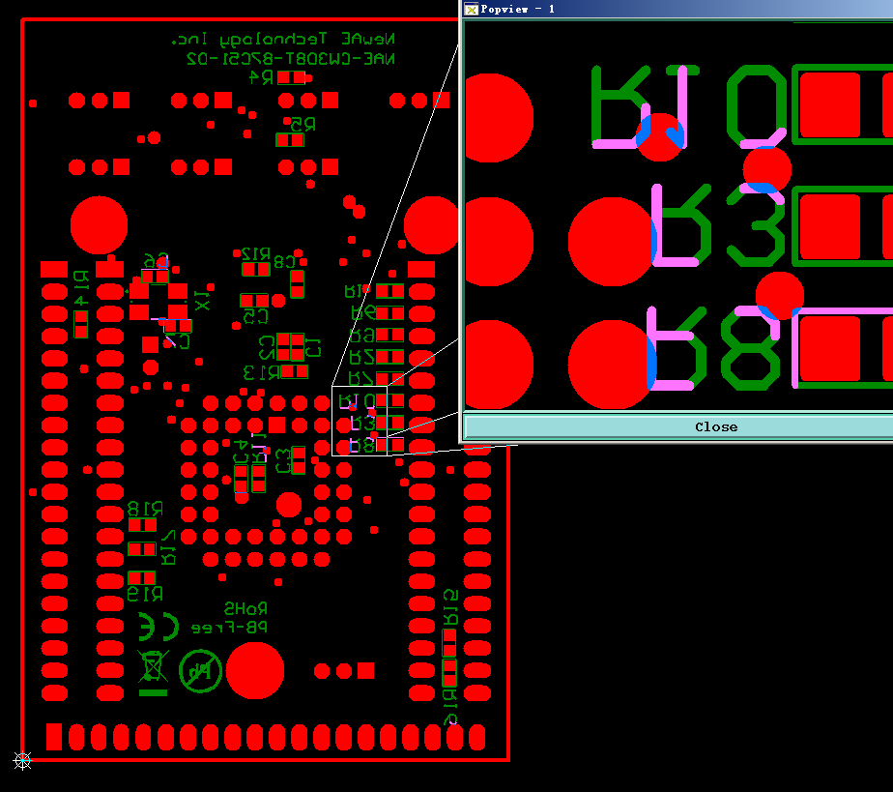 | Suggestion:  Clip off these texts which step on the pads,and fuzzy and incomplete texts are acceptable. | Please clip texts.
Best regards,
Eng Group

